Owari Rules

The game of Owari is one of many variants stemming from the game of Mancala. This document defines the rules for this particular version of Owari.

What is Owari?
Owari is a two-player game, played by strategically moving and capturing pieces to score points. Players, referred to as North and South, are assigned six pits, each of which initially contain three stones. Each player also possesses a goal pit, representing their respective score. The initial game board is set up in the following manner:

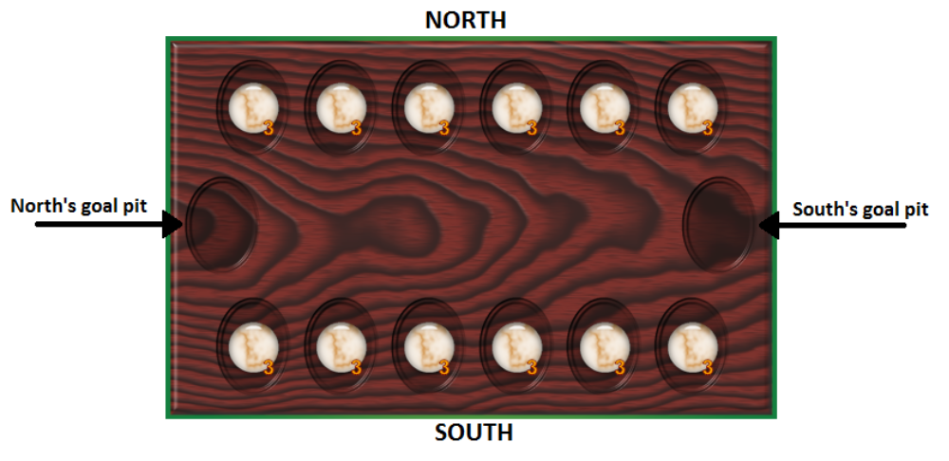
Moving
Each player makes one move per turn. To make a move, a player must select a non-empty pit from one of their six respective pits. All of the stones are removed from the selected pit and redistributed in a counterclockwise direction, placing exactly one stone in each subsequent pit, including the moving player's goal pit, until none remain. If an opponent's goal pit is reached, it is skipped and the stone is placed in the following pit. A move could potentially wrap around the board several times given enough stones.

The following picture depicts the result of a move by player South from the initial game state by selecting their fifth pit:

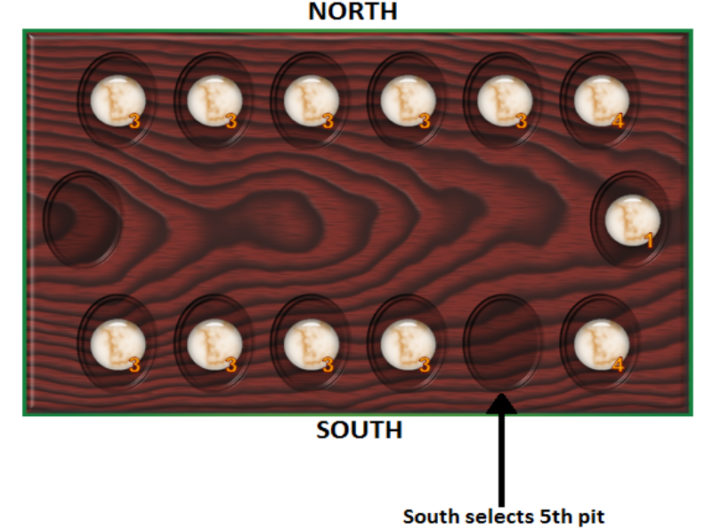
Capturing
A capture results when the last redistributed stone of a move lands in a pit belonging to the moving player. In this case, the moving player removes all of the stones contained in the opponent's pit lying directly opposite to the moving player's pit, and places them in their own respective goal pit. Considering the previously depicted game state, and assuming it is South's turn, South can make a capture by selecting their second pit for their move:
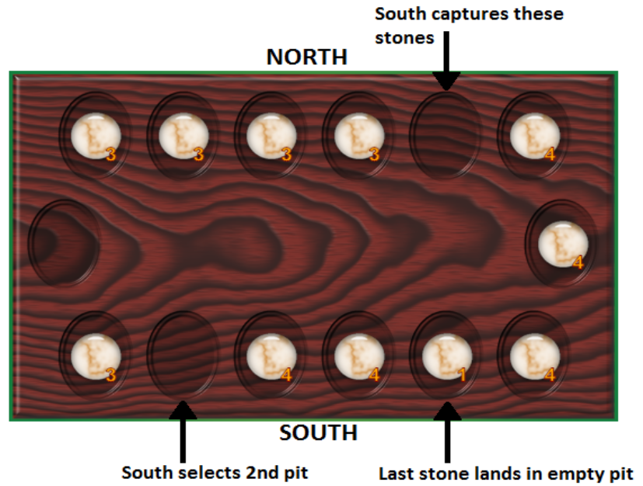

End of the game
The game ends when one player no longer possesses any stones in any of their six pits. The player with remaining stones places them all in their own goal pit. The player with the most stones in their own goal pit wins the game.

